**Background**

Crowdfunding platforms like Kickstarter and Indiegogo have been growing in success and popularity since the late 2000s. From independent content creators to famous celebrities, more and more people are using crowdfunding to launch new products and generate buzz, but not every project has found success.

To receive funding, the project must meet or exceed an initial goal, so many organizations dedicate considerable resources looking through old projects in an attempt to discover “the trick” to finding success.

**Objective**

The goal of this Challenge, is to organize and analyze a database of 1,000 sample projects to uncover any hidden trends using Excel Analysis.

**Conclusions**

1. According to the dataset analyzed, it is observed that fundraising through Crowdfunding platforms like Kickstarter and Indiegogo have 73% average chance of success as compared to 25% chance of failure and 2% chance of cancelation. It was interesting to find that projects with Goals between 15000 to 19999, 20000 to 24999 and 30000 to 34999 saw 100% rate of success, although it is worth mentioning that these were small amounts of projects; about 24 out of over 82 total. The least rate of success projects fell within the goals of 50000 and above. Fundraisers would like to take note of the goal range as they launch their campaigns.

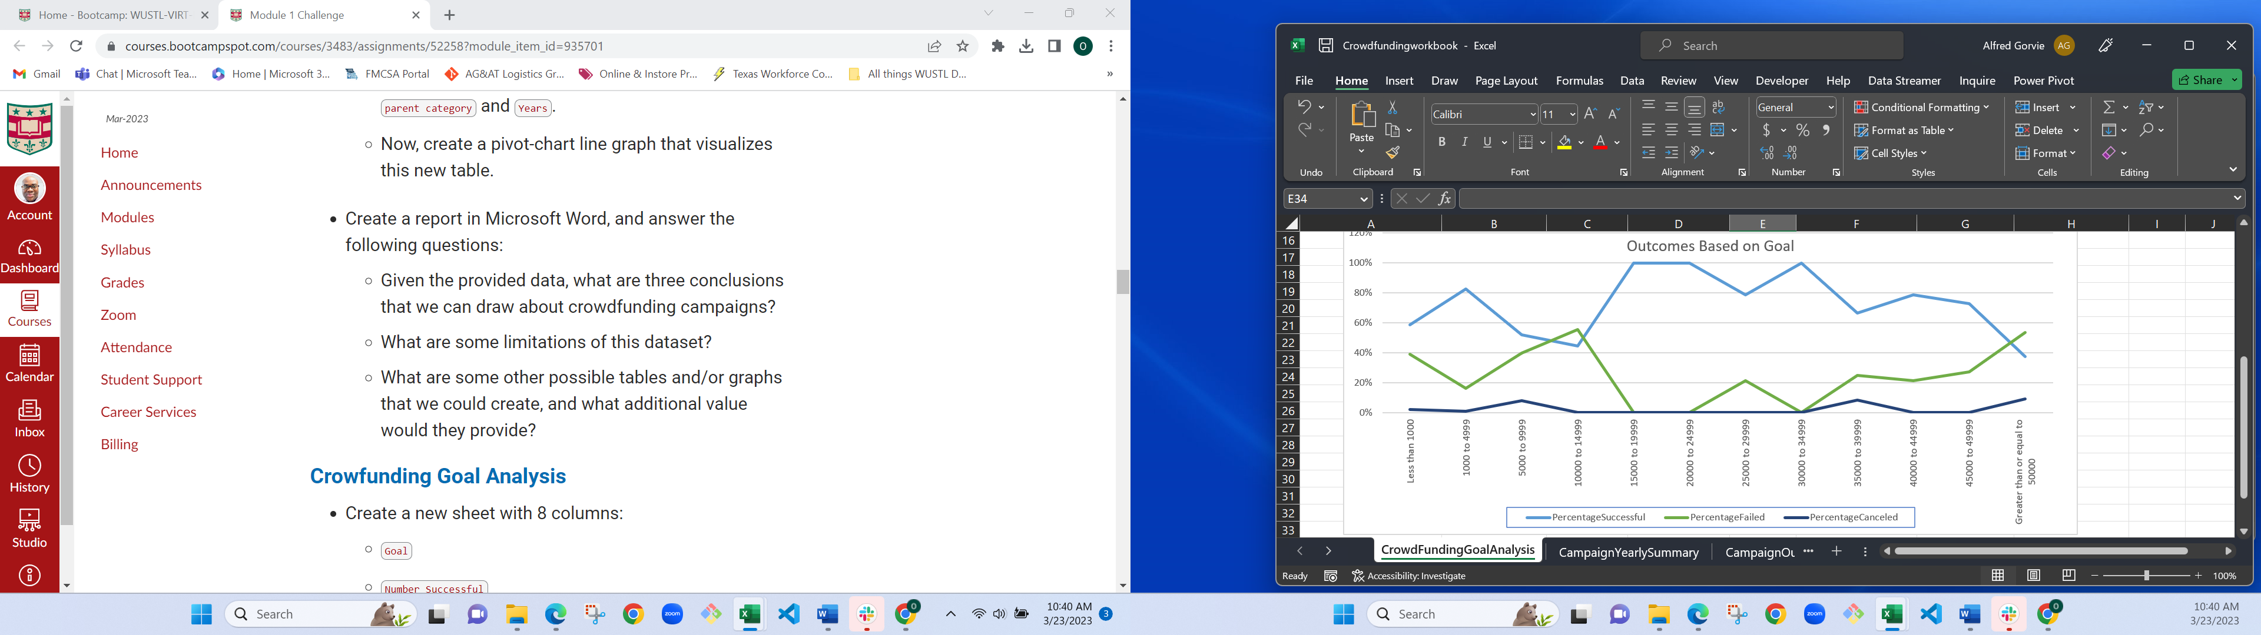

1. Furthermore, looking at campaign summary by category, theater especially Plays seemed to perform better than all the other categories with 187 successes out of a total of 344 and it was also the category with the highest total of campaigns. In second place was Film and Video with 102 out of 172 successes. The least performing categories were Photography, Games and Food; an information backers might find interesting when supporting future projects. It is interesting to note that 100% of Journalism campaigns were successfully funded although it is worth noting the total number of campaign (4) was very small to make viable conclusions but it could be a good start for future campaigners.

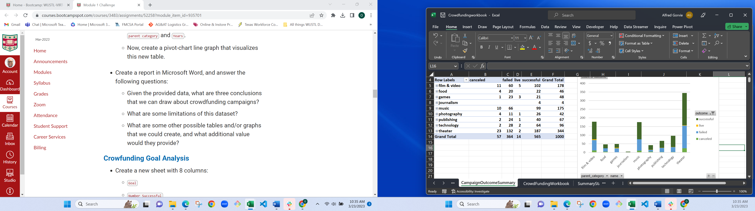

1. Lastly, the data shows that campaigns were at their highest point of yearly success in June and peaks in July. Success rate deeps considerably in August and continues the low trend up to December. Also, chances of failure and cancelation goes up in December while success rate falls. The data shows, it will be more advantageous for Campaign launchers to kickstart in the height of the summer months in order to increase their success rate.

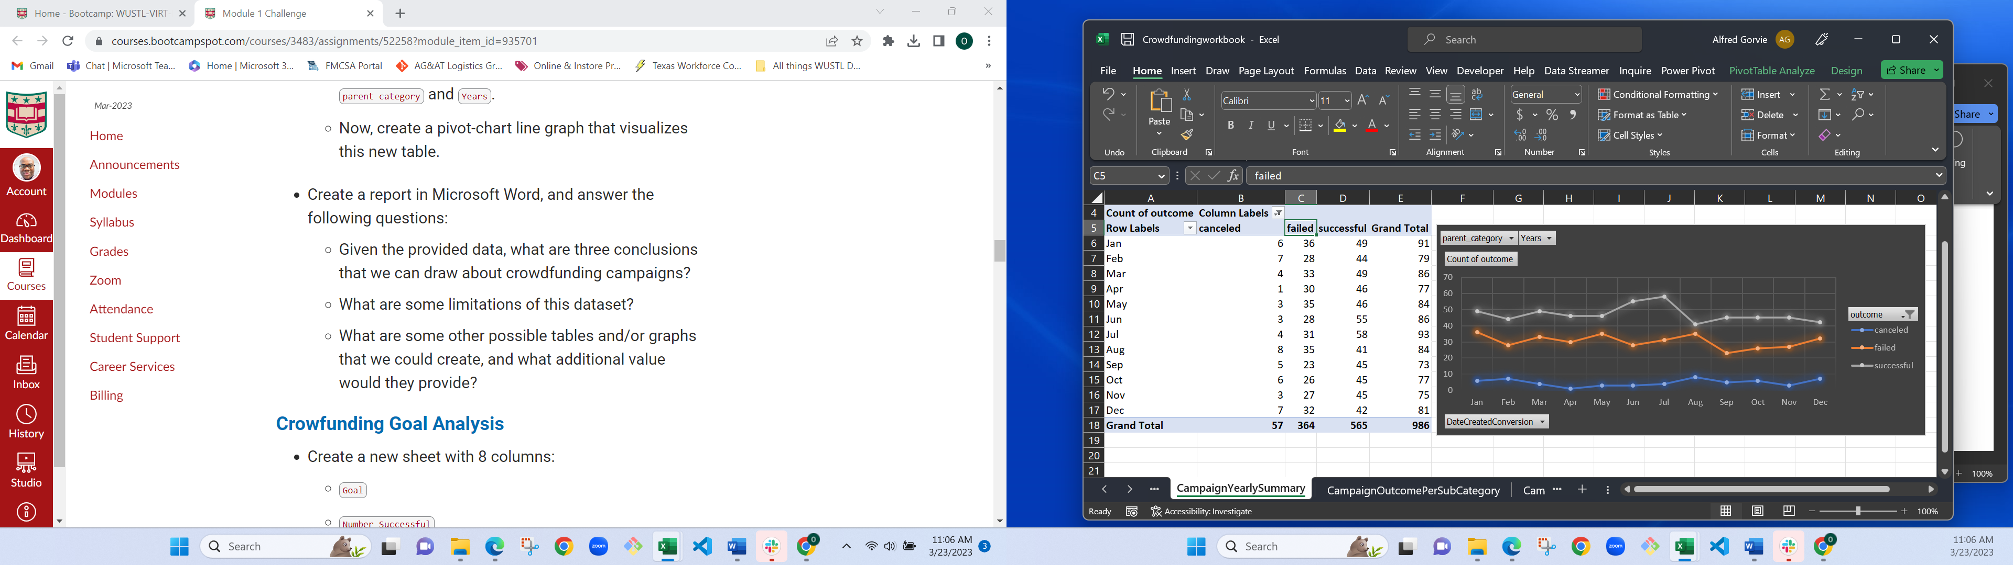

**Limitations of Dataset**

* A major limitation found in the dataset is the limited amount of data in categories and subcategories to be able to make a reliable statistical conclusion. For instance, even though 100% of journalism campaigns succeeded the sample only have 4 entries which is not enough to make a judgment on viability.
* We might also need more data on how much visibility and publicity the various categories received.

**Recommendations for further analysis**

It will be interesting to do more analysis on how long the projects took and if the length of time impacted the rate of success.

Also, use of Scatter plots charts can help in identifying other patterns in the dataset including success and failure rate variables, outliers etc.